Executing Git Clean-Up, Pull, and Push Commands:
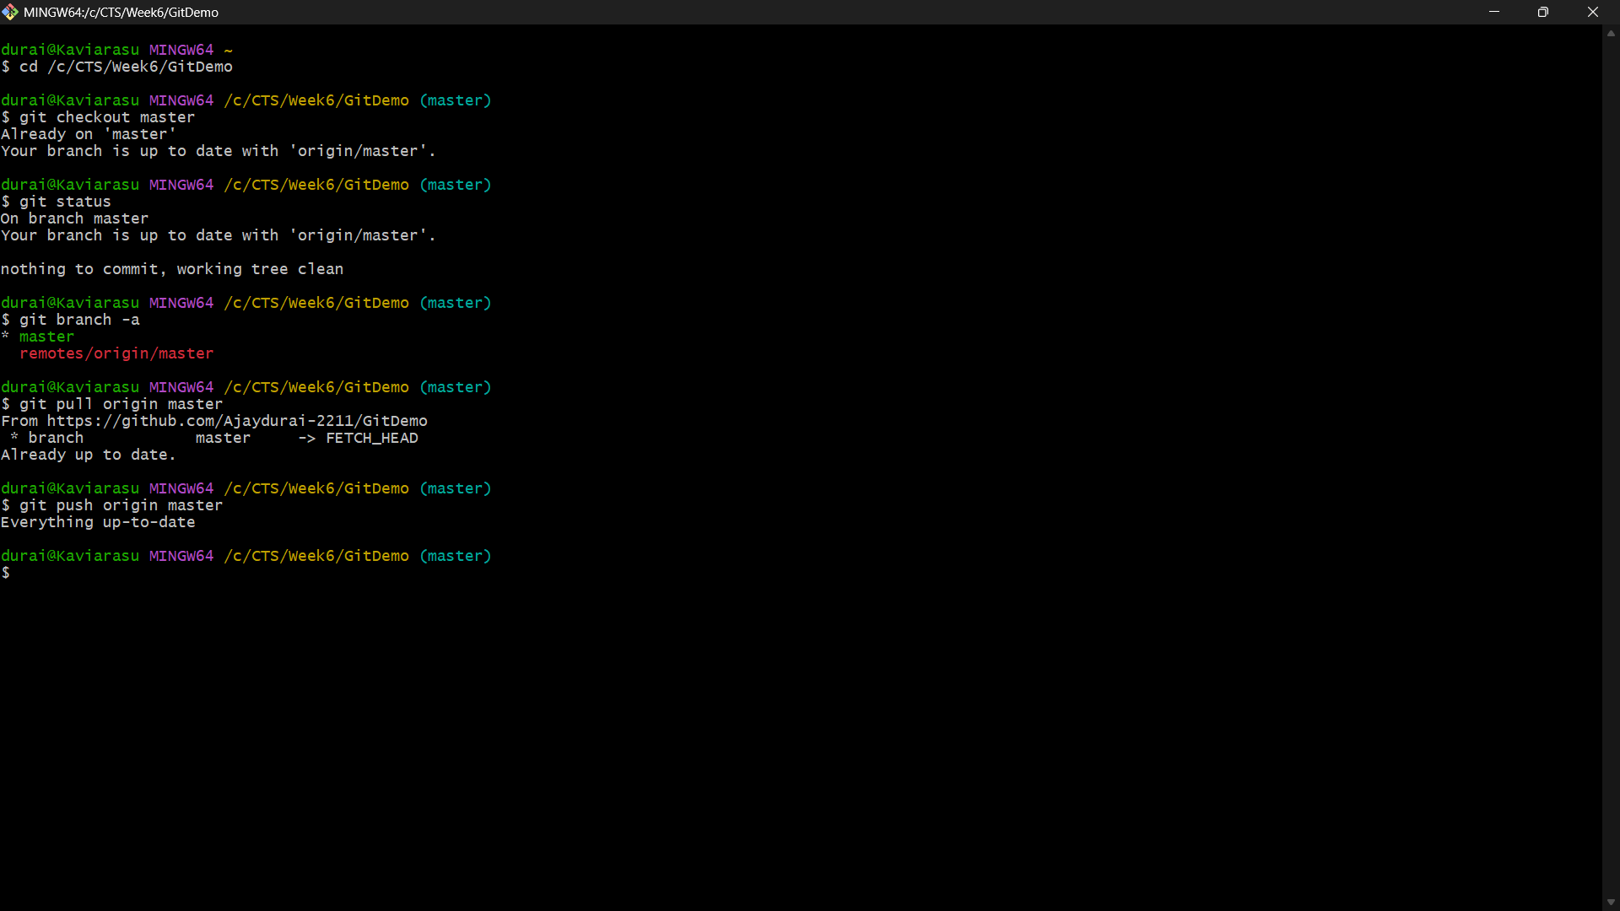
Verifying the Updated Repository on GitHub:
